**Function declaration**

Function declaration is a function defined with function declaration must begin with **function** keyword

**Syntax:**

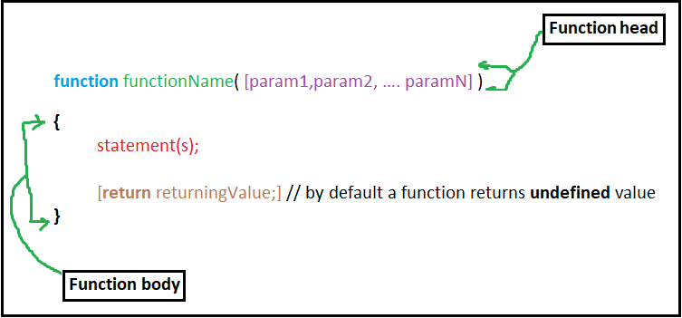

**Note:**

* Return statement In the previous syntax is an optional statement as if a function has an arguments then it should has returning statement and if the function hasn’t parameters, then it shouldn’t has returning statement.
* Return value in function by default is **undefined.**
* Functions doesn’t execute by itself, It executes only when we call them.
* We can call one function several times and in anywhere.

**Example:**

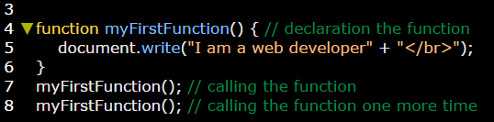

**Example 2:** make a financial converter from dollar to EGP.

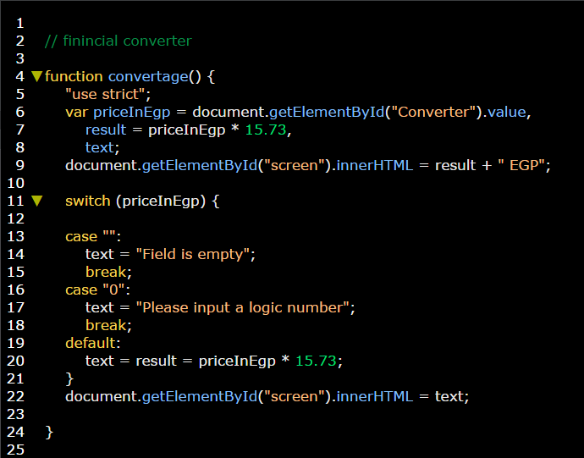

**Example 2:** make a financial converter from dollar to EGP. Still working

